Reviews

**Page 20**

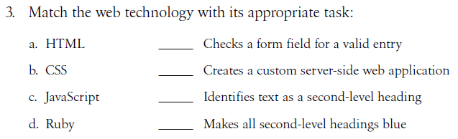

**Page 34**

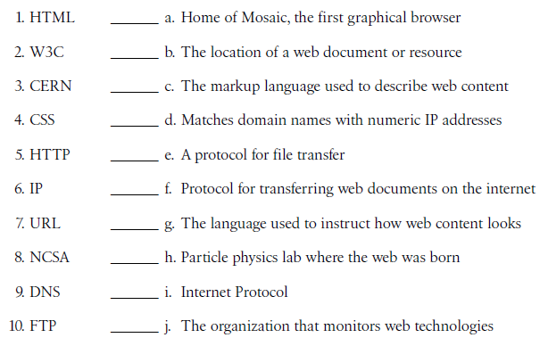

**Page 40**

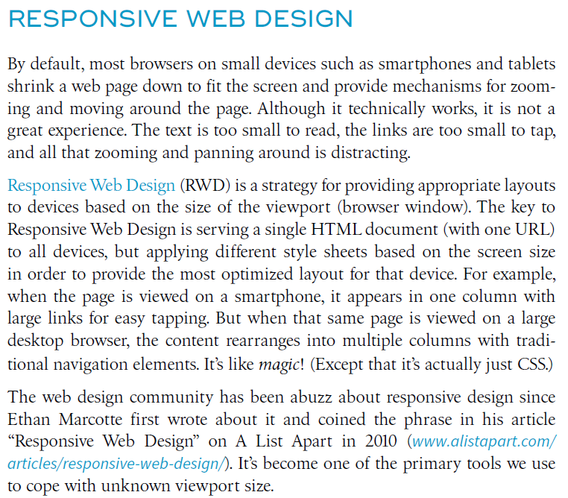

**Page 111**

5. How do you remove the bullets from an unordered list? (Be general, not

specific.)

**Page 129**

Create a link to friends.html from acorn.html

**Page 159**

1. Which attributes must be included in every **img** element?

**Page 175**

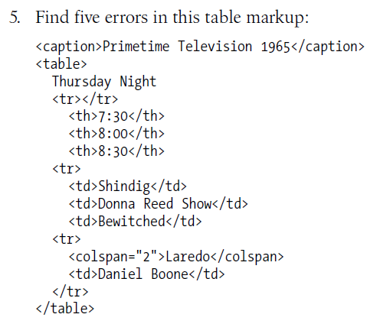

**Page 208**

